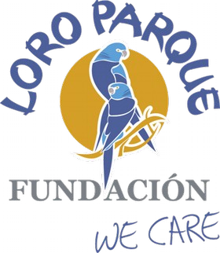
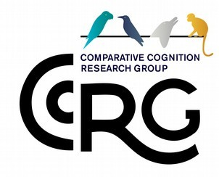

Opportunity!

Projects available for Master’s students and self-funded guest researchers in Comparative Cognition Research Station at Tenerife, Spain run collaboratively between the Max-Planck Institute for Biological Intelligence and the Loro Parque Foundation

The Max-Planck Comparative Cognition Research Group (CCRG)
https://www.bi.mpg.de/von-bayern
invites applications from Postgraduate/Undergraduate students and Interns who want to assist in research projects and bird care, enrichment and management. The CCRG is part of collaboration between the Max-Planck Institute for Biological Intelligence, Germany, and Loro Parque Fundación (LPF) in Tenerife, Spain. We are currently carrying out several projects on parrot intelligence. We work with mostly tame, captive parrots of LPF, which owns the largest collection of parrots and genetic reserve in the world (approximately 350 subspecies) for conservation and research purposes. Interested candidates are encouraged to contact us to request information about ongoing projects. Selected applicants will gain experience in the field of cognitive research, as well as working with and training exotic parrots in a highly dynamic international research environment. A unique opportunity!

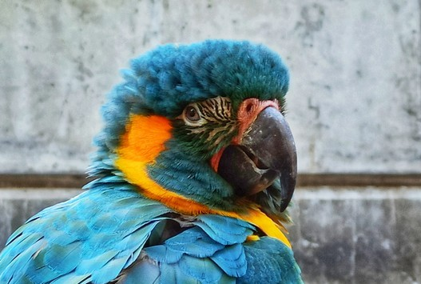
Preferable time of joining:

It is highly preferable if students can join by April/May 2024

Logistics:

The projects for Master’s theses and guest researchers require a minimum of 4 months but ideally 6 months of continuous commitment at the research station in Tenerife, Spain.
Accommodation can be provided in a shared student apartment (Puerto de la Cruz, Tenerife, Spain), with affordable facilities. Students with their own funding or grants can apply for the posts.

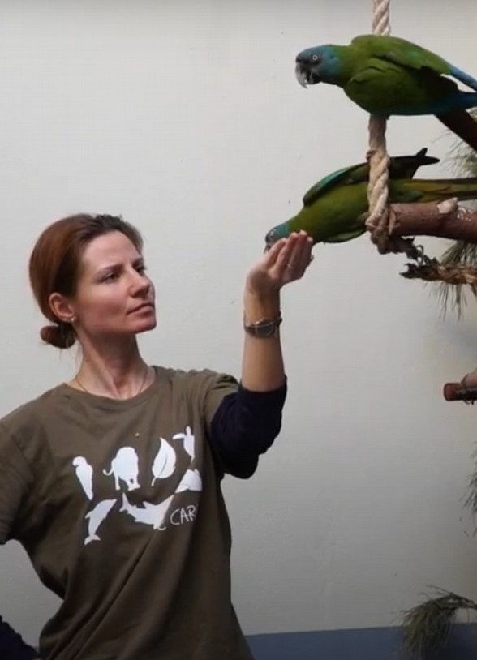
Important skills/qualifications:

Selected candidates need to have:

- High motivation and commitment to the care of our birds

- Preferably pursuing Master’s degree in Biology/ Psychology/Animal Science or related subjects.

- Reliability, efficiency and ability to work independently

- Confidence to interact with animals

- Good verbal English skills

- Good teamwork attitude and social skills

Submit your request!

For more information on how to apply, please email Dr. Anastasia Krasheninnikova (akrasheninnikova@bi.mpg.de)

